**Course:**

**Software Engineering - COMP-6905-001**

**Project:**

**Skier-Routing app**

**Iteration # 01**

**Group # 12**

**Group Members:**

**Name Student Number**

1. **Jinhao Luo 202388555**
2. **Nakash Kumar 202381669**
3. **Osama Ahmed Masood 202389195**
4. **Rahul Subramanian 202382981**

**Table of Content**

1. Cover Page……………………………………………………………………………………...01
2. Table of content…………………………………………………………………………………02
3. Three Main Use cases…………………………………………………………………………03
4. Additional use cases……………………………………………………………………………07
5. Use case Diagram……………………………………………………………………………...08
6. Domain Model……………………………………………………………….………………….09
7. Sequence Diagram…………………………………………………………..…………………10
8. Iteration 01 Checklist.…………………………………………………………………………..11
9. Links to Github ………………………………………………………………………………….11
10. Link to the Deployed Landing page ………………………………………………………….11

**Section 01:**

**Three Main Use Cases**

**Use Case 01: Search Route.**

| Use-case Name | Search Route |
| --- | --- |
| Participating Actors | Skier |
| Flow of events | 1. The skier opens the ski routing app. 2. The system sets the skier’s current location as the starting location. 3. The skier selects a location on the map. 4. The skier marks the selected location as the ending location. 5. The skier initiates the search. 6. The system calculates and displays a default route on the map and shows its details. 7. The skier uses the provided route to navigate to the ending location. |
| Alternative Flows | 4a. The skier marks the selected location as the starting location:  1. The skier selects another location.  2. The skier marks the selected location as the ending location.  (Continue to step 5 of the main flow of events)  5a. The skier customizes query parameters for advanced search:  1. The skier selects to show the shortest route.  2. The skier selects a slope interval of 0 to 45 degrees.  (Continue to step 5 of the main flow of events)  7a. The skier wants to see other displayed routes:  1. The skier selects other displayed routes.  2. The system highlights the selected route and updates its details.  3. The skier uses the new route to navigate to the ending location. |
| Entry condition | * The skier needs to be in the ski resort map and there needs to be at least two selectable locations(including ski locations and special locations). |
| Exit condition | * The skier selects a satisfactory route, or the skier chooses to exit route planning. |
| Quality Requirements | * The system needs to display the route planning results within 5 seconds after the skier initiates the search. * The route planning results need to be clear and easy to understand. * The system needs to be able to handle various complex terrains and route combinations. |

**Use Case 02: Filter Map.**

| Use-case Name | Filter map |
| --- | --- |
| Participating Actors | Skier |
| Flow of events | 1. The skier opens the filtering menu on the map. 2. The system shows a list of available filters to the skier which include options such as: 'Restaurants', 'Restrooms', 'Chairlifts', 'Slopes and Ski Routes', 'Ski Buses', and other such available filters. 3. The skier selects the option that he wants to filter the map view by. 4. The system updates the map according to the skier's criteria and presents the updated version to the skier. 5. The skier selects additional filters while the first filter is active. 6. The system filters the map by all the selected filters and updates the view respectively to show all the filtered results combined. 7. The skier uses the filtered map to navigate the resort. 8. The skier unselects one or more filters that were previously selected. 9. The system updates the map by removing the results of the removed filter from the view. 10. The Skier navigates the map with any or no filters active. |
| Alternative Flows | 4a. The result after the filter is empty   1. The system shows the skier an empty map.   6a. If there is no data for any of the selected filters there are   1. no changes in the map view. |
| Entry condition | * The skier has successfully accessed the Skier-Routing app on a mobile device. * The app has up-to-date and accurate map data of the ski resort. |
| Exit condition | * The map displays only the filtered information according to the skier's preferences. |
| Quality Requirements | * Filtering actions should be intuitive and require minimal clicks/taps. * The map should update quickly after applying filters to provide real-time information. |

**Use Case 03: Check Location Details.**

| Use-case Name | Check Location Details |
| --- | --- |
| Participating Actors | Skier |
| Flow of events | 1. The skier opens the ski resort navigation web app. 2. The system loads the map of the ski area, displaying slopes, restaurants, restrooms, and chairlifts. 3. The skier selects a specific location on the map (slope, restaurant, restroom, chairlift). 4. The skier selects a slope on the map. 5. The system retrieves and displays information about the slope's difficulty and the trail length. |
| Alternative Flows | 4a. The skier selects a restaurant.   1. The system retrieves and displays information about the restaurant’s cuisine and operating hours.   4b. The skier selects a chairlift.   1. The system retrieves and displays information about the chairlift’s capacity.   4c. The skier selects a restroom.   1. The system retrieves and displays information about the restroom’s operating hours. |
| Entry condition | * The skier has successfully accessed the Skier-Routing app on their mobile device. * The skier interacts with the map by selecting a location. |
| Exit condition | * A pop-up panel is displayed with the relevant information based on the type of location clicked. |
| Quality Requirements | * The pop-up panel displaying information should appear quickly after the skier selects a location on the map. * The system should be able to handle an increased number of skiers during peak times without a significant degradation in performance. |

**Section 02:**

**Additional use cases**

1. **Identify Current Location**: Establish the skier's current position using the mobile device's GPS.
2. **Choose Slope difficulty**: Enable skiers to set their desired level of slope difficulty (blue, red, black).
3. **Find Public Restrooms**: Show locations of public restrooms within the ski area.
4. **Purchase Resort Ticket**: The skier goes online, selects everything he wants and pays for it to get a pass for the resort.
5. **Check Lift Status**: Display the operating status of nearby lifts (open, closed, wait times).
6. **Book Restaurant Reservation**:
7. **Report Emergency**: Provide a feature to request help or medical assistance.
8. **Rent Equipment**: Allow skiers to rent skiing equipment through the app.
9. **Receive weather update**s: Skiers can check the weather for the slopes in the resort.
10. **Display Route**: Show the calculated route on the map.

**Section 03:**

**Use case Diagram**

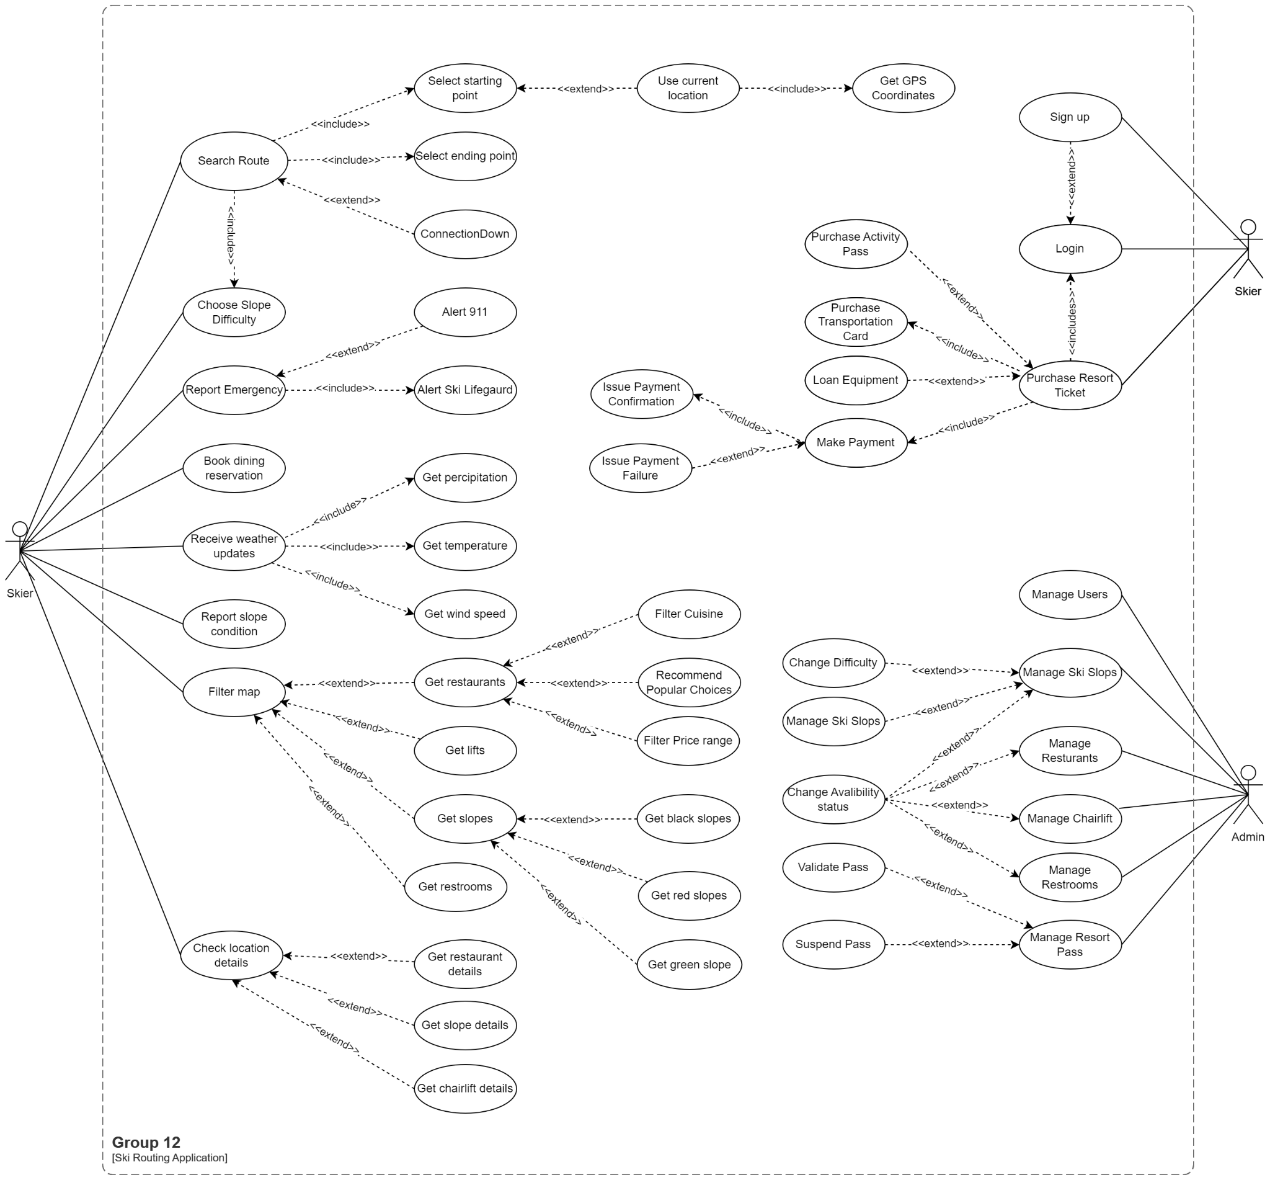

**Section 04:**

**Domain Model**

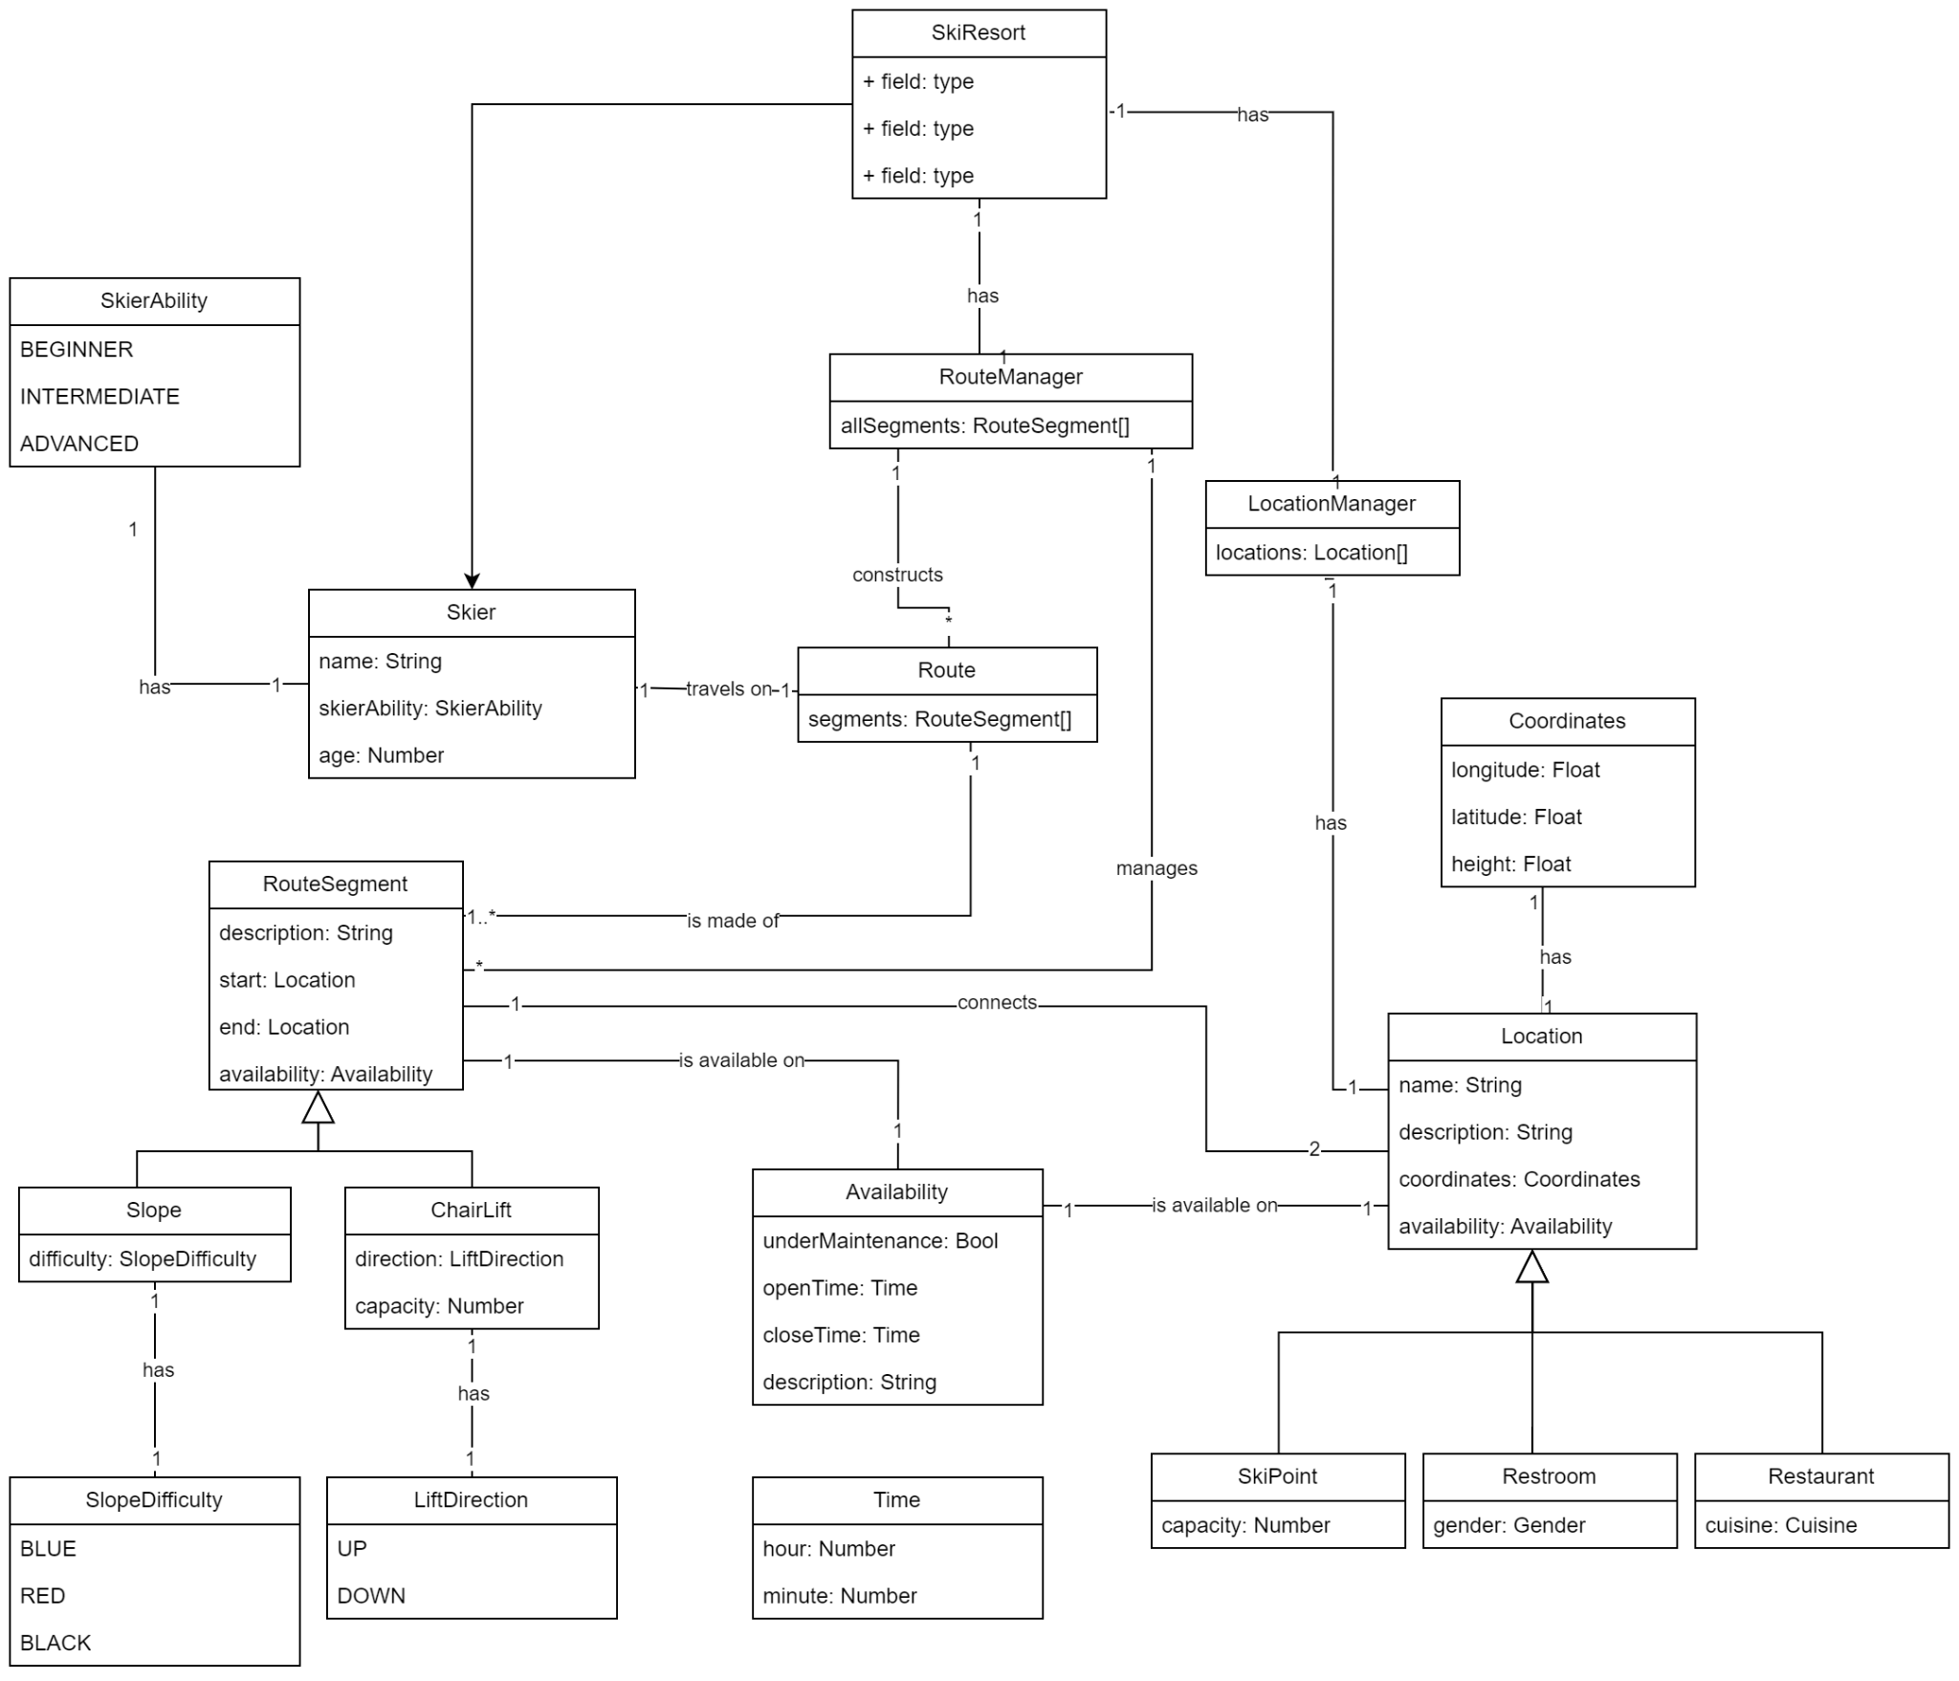

**Section 05:**

**Sequence Diagram**

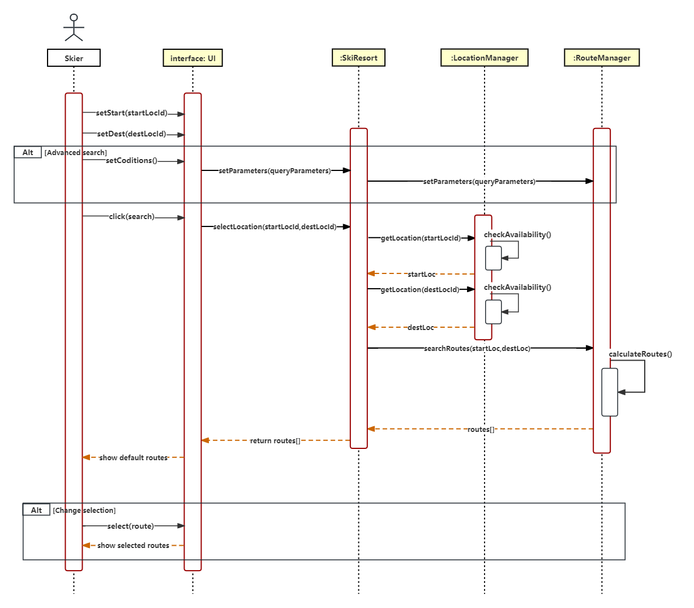

**Checklist Iteration 01 for completed tasks:**

* **Create a group Github and add TA and Professor to it.**
* **Create a server and Deploy a simple Landing page for the Project.**
* **Give two to three main use cases of the system in detail.**
* **Give names of additional use cases.**
* **Create a Use Case Diagram.**
* **Create a Domain Model.**
* **Create a Sequence Diagram.**

(Completed 7 of 7)

**Links:**

Website Deployed:

<https://mun-comp-6905-group-12-ski-routing-app.vercel.app/home>

GitHub Repository:

<https://github.com/MunSoftwareGroup12/software_project>

(END)